**Project Planning**

**Use case:**

Water usage and level monitoring and remote control of motor.

Most of the homes in India where I come from has wells or underground water reservoirs or rain harvesting tanks that are the water source or bigger reservoir to store water. Water is pumped from these reservoirs to overhead tanks manually so that desirable water pressure can be achieved in the faucets. Since the water pump motor is controlled manually people turn off the motor when the tank overflows which leads to wastage of both electricity and water. Also in cases where the multiple households share the same water tank and one has duty to control it, that person has to be home always to make sure that other people get unhindered water supply. So my solution is to install a water level monitoring system in the water tank and measure and share the water level in realtime to a database and display the information on a webpage. A notification can be sent to the user when the water level gets too low to 20 percent. By installing a smartswitch to control the motor the user can turn the motor ON and OFF from anywhere in the world. The water level data can be used further to monitor the water use in the household and thereby avoid water wastage if there is any.

The water level will be measured by using an ultrasonic sensor that measures the distance to an object by transmitting and receiving ultrasonic sound waves. Ideally data should be collected from a real world setup. Since that’s impossible in my case, I will either build a small prototype and measure the data or simulate the data with a program for the execution of the project.

The target group for the project are home users who are interested in automation of water tanks.

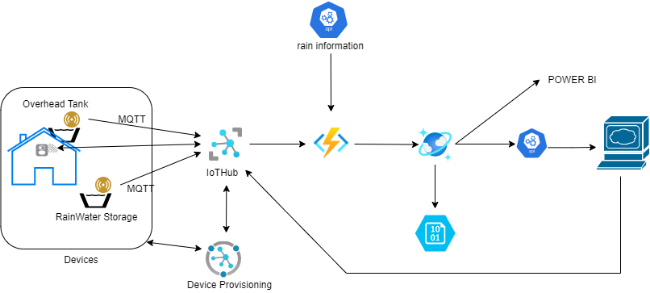

**Use case:**

Smart food storage Shelves

Food containers with passive RFID level Sensor tags and Shelf units with RFID reader that can read the sensors and deduct the value of food level in the containers to cloud database and display it in a webpage. Eventually add the food that are low in level to a shopping list.

One of the biggest differentiators of Azure Static Web Apps is the ability to integrate them into Azure DevOps or GitHub, meaning you can have an ‘out of the box’ fully automated system